Abstract

The Client to whom we did the project is Radiant Confectioners. The company is involved in sales and distribution sector. They have 61 sales representatives all around the country in different areas managed by area managers. These sales representatives of the company are involved in distributing the products to the shops that requires them.

Our Client wanted us to develop a web application to manage their Sales and Distribution process through the web as at the present they have system where they do almost all of their work manually .The drawback of the current system is that there is a lot of time delays and the data which is gathered is sometimes inaccurate which could lead to disruptions in decisions made by the management of the company.

Iterative waterfall method was used as the software development life cycle. Coding was handled through an Object-oriented approach. Above mentioned methodologies made project work load light and provided the ease of developing. The system was evaluated by several people regarding user levels of the developed system. Results of the evaluation helped for further maintenance of the product. Fully functional Radiant Management System will fulfill the main objectives and all the events of the company.

Acknowledgement

We would like to express our very great appreciation to our supervisor Mr. Ishara Gamage for his valuable and constructive suggestions during the planning and development of this project. Her willingness to give her time so generously has been very much appreciated. Advice given by other academic lecturers has been a great help in building the software solution. Also we obliged to staff members of Radiant Confectioners, for the valuable information provided by them in their respective fields. We are grateful for their cooperation during the period of developing the system.

Declaration

We declare that the this project report or part of it was not a copy of a document done by any organization, university any other institute or a previous student project group at SLIIT and was not copied from the Internet or other sources.

Project Details

|  |  |
| --- | --- |
| Project Title | Sales Management System |
| Project ID | ITP-15-MLB-B1-03 |

Group Members

|  |  |  |
| --- | --- | --- |
| **Reg. No** | **Name** | **Signature** |
| IT14090486 | Sachintha Sandaruvan K.A. |  |
| IT14098192 | Chandrasena T.K.S.C |  |
| IT14095818 | Ali Nauf |  |
| IT14024382 | Pradeep A.W.A. |  |
| IT14091476 | Liyanage D.L.K.S |  |
| IT14096976 | M A Zaman |  |
| IT14001758 | Bandara G.M.B.B.O |  |
| IT14086076 | Hamzath Anees |  |

Table of Contents

1. Introduction 1

1.1 Problem Statement 1

1.2 Product Scope 2

1.3 Project Report Structure 3

2. Methodology 4

2.1 Requirements and Analysis 4

2.2 Design 9

2.3 Implementation 11

2.4 Testing 14

3. Evaluation 15

3.1 Assessment of the Project results 15

3.2 Lessons Learned 15

3.3 Future Work 15

4. Conclusion 16

5. References 17

Appendix A: Design Diagrams 18

List of Figures

Figure 1: 5

figure 2: 5

figure 3: 6

figure 4: 6

figure 5: 7

figure 6: 7

figure 7: 8

figure 8: 8

figure 9: 9

figure 10: 10

figure 11: 10

figure 12: 13

figure 13: 13

figure 14: 18

figure 15: 19

figure 16: 20

List of Acronyms and Abbreviations

D.S.R – Daily Sales Report

# Introduction

## Problem Statement

Radiant Confectioners are implementing a manual process at the current moment do their processes. The creation of invoices, reports, billing and calculations are all done manually by staff.

There are more than 60 sales representatives of the company who sell the goods to the customer and create invoices for each customer. On average they make around 50 invoices per day. Hence per each day there will be around more than 3000 invoices (60x50) created by all the sales representatives around the country. These invoices if done manually would require a lot of time and diligence for the main branch to track and monitor the sales since the data entries would be very large.

At end of each day the sales representative have to create a Daily Sales Report (DSR). This is a report which involves calculations based on the products sold during that day. If there were calculations which result in errors the data’s in the reports would depict inaccurate information.

Our group was told by the company that these were mistakes which are being done by the sales representatives occasionally.

At the end of each month the daily sales reports made by the Sales Representatives will be sent to the main branch of the company. Each Sales Representative would have at least 27 daily sales reports. So the company would receive about more than 1620 Daily Sales Reports. Out of these Daily Sales Reports the company would create other reports and charts as well.

Some of these are:

• Actual Sales

• Product Sale according to District

• Product Sales according to dealers

• A chart about Sales accrued by Sales representative

• Sales pattern and history

• A product’s demand and its trend

Since these reports and charts are also done manually, the problems that we pointed out above also apply to these as well.

The Management of the company has difficulty in analyzing the data to make key decisions and plans because the manually gathered data and reports are very difficult to organize because the documents of its other branches cannot be accessed remotely and the inaccuracy of the data results in weak reports.

So to sum it all up the following are disadvantages of the old system:

1. Time Consuming

2. Less accurate

3. Less efficient

4. Lots of paper work

5. Slow data processing

6. Difficult to keep and find old records

Through the development of the Sales Management web application our goal is to automate the company’s sales and distribution processes as at the present they do almost all of their work manually.

## Product Scope

The sales management web application which our team developed for Radiant Confectioners would help in automating all the main operations in the sales and distribution cycle of their company.

Sales representative can make use of this web application to create invoices in through their device after which the invoices will be printed by mobile printers. So the constraint of writing invoices manually could be alleviated which would result in higher productivity.

After the data for the invoice has been entered, these data would be then stored in the main database

A daily sales report would be then generated automatically so the sales representative would not have to worry about calculations involved in and delivering the daily sales report to the company. The Sales Representative can also view the daily sales report and his sales history from the device. There could also be automated reports and charts which could be generated for the management as well as the staff so that the decision making and the planning process for future distribution cycles would be easy and structured better.

Some of the key benefits of the system are:

* Hours of manual calculations would be eliminated by the automated system, inaccuracy is also removed.
* A web based system will eliminate any special device requirements; even mobile phones can be used to access the system.
* The web based systems provides the most efficient means to sync data. Hours of manually syncing, rewriting is eliminated.
* Data security is implemented. Only authorized will be able to access the important data’s of the company.
* Backups are stored in remote locations other than in the office cabinets.
* Real time tracking of sales information is provided, something the company never had previously.

## Project Report Structure

This project report done for the company ‘Radiant Confectioners’ is fully done by following the document standards of IEEE. It is done so that the reader would be able to fully grasp the idea and information of the report in a well-mannered way. If this project would be continued to be developed to further enhance the capabilities of the web application, the development team could refer the document for clarifications and understanding of the application to set future goals and modify the application.

# Methodology

## Requirements and Analysis

Gathering required information was done through the interviews by visiting their head office situated at Sapugaskanda. During the interviews we carefully studied the users who will use the system, and we targeted our interviews conducted around them. General Manager, Sales and Marketing officer, numerous others who are in charge of accounting, sales representatives who are carrying their work on the field actively (who visit number of shops) and etc. A challenge faced is to get the overall view of the users as they were mainly concerned mainly on product and invoice part.

Since company’s staff are end users who are non-technical these interviews were a new experience to them as well. We got the opportunity to accompany the sales representatives while they were selling products to the customers and observe the way how the process work. After gathering and analyzing the client requirement it was expressed by a use case and the rest of the development process was built on it. However after the feasible study we were able to carry out the process according to the 2nd phase of the ideal waterfall model, which is the requirement and gathering phase, and there after by considering the latest models such as which goes according to agile development, we tried to iterate the phase. That is we combined the concepts of prototypes as well as several concepts of the scrum and extreme programming as well. An iteration of the process consisted of a mini project which had the objective of completing the client’s requirement as a working prototype before the next interview. This gave us the flexibility to adapt and to make the required changes in time. Also the client’s satisfaction was high.

After gathering requirements we were able to use UML modeling techniques as well. We as for starting the process, created use case diagrams.

**Activity Diagram**

Figure 1:

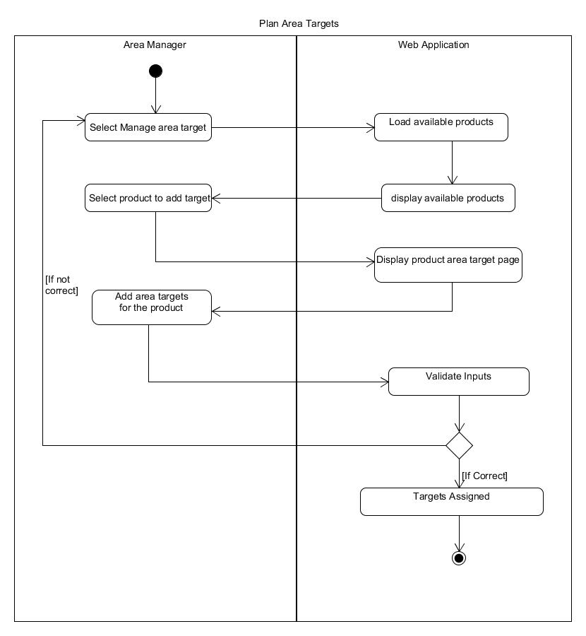

figure 2:

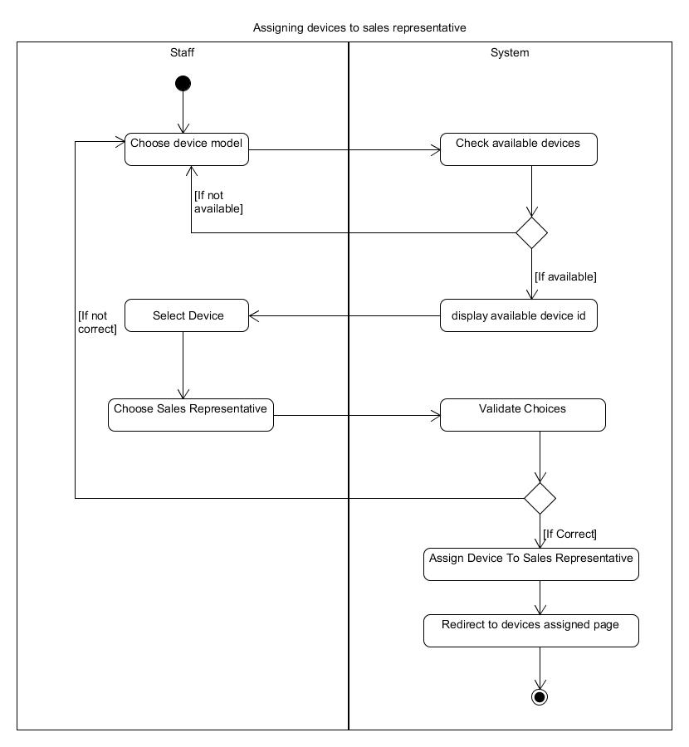

figure 3:

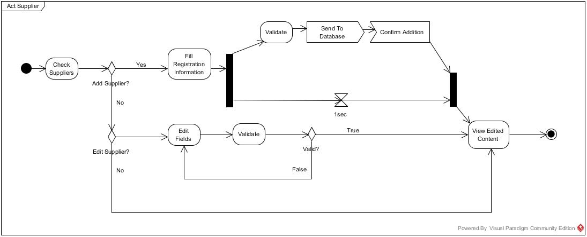

figure 4:

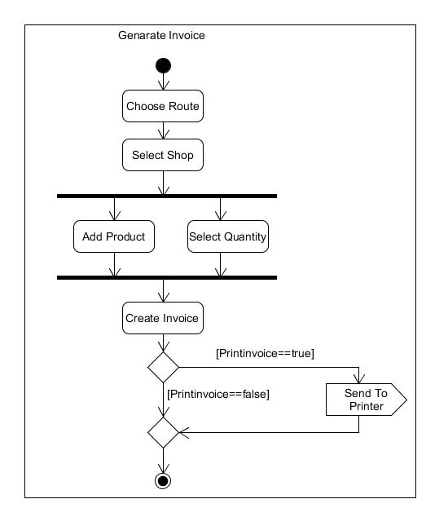

figure 5:

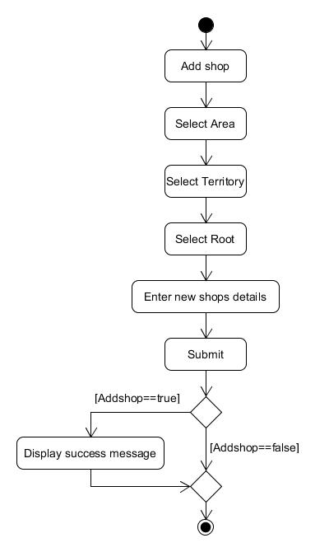

figure 6:

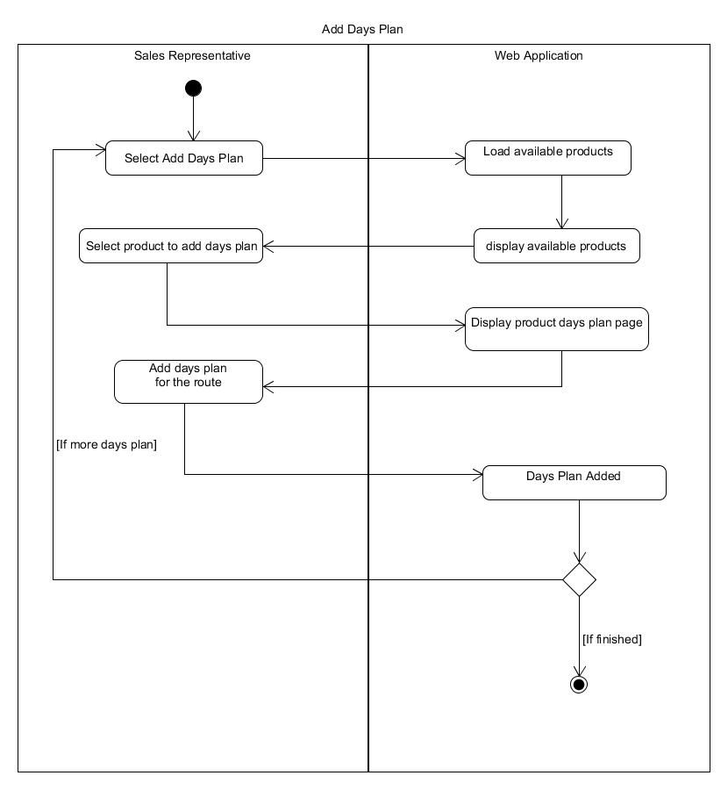

figure 7:

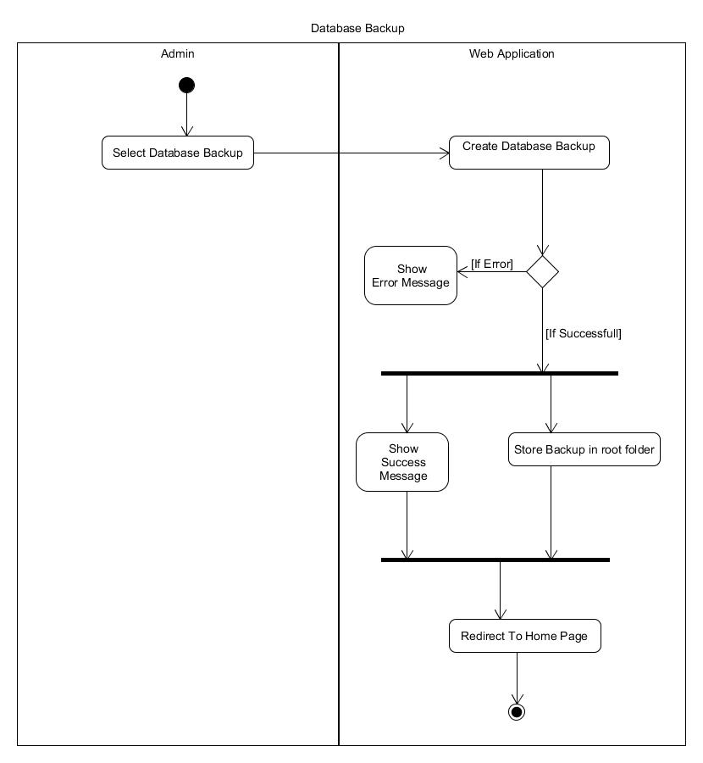

figure 8:

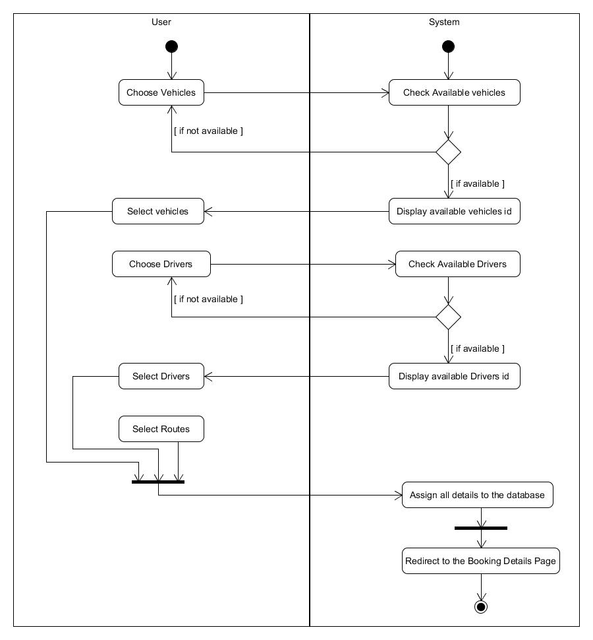

## Design

Project was designed using an object oriented approach. While developing the system we had to come across several diagrams in order to achieve the quality of the software product. After creating the ER diagram it was mapped to a relational schema and normalized. Finally the database was created. Class diagram was designed with class stereotypes which included with relationships. Class diagram helped in programming the solution.

**Class diagram**

figure 9:

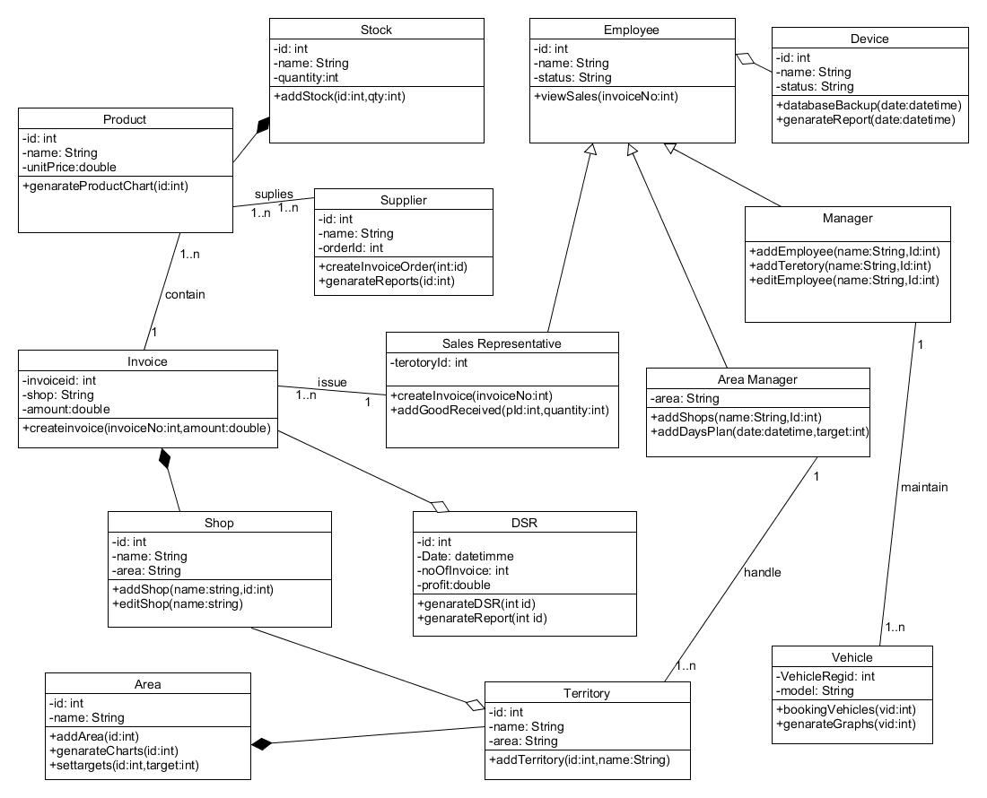

**Sequence Diagram**

figure 10:

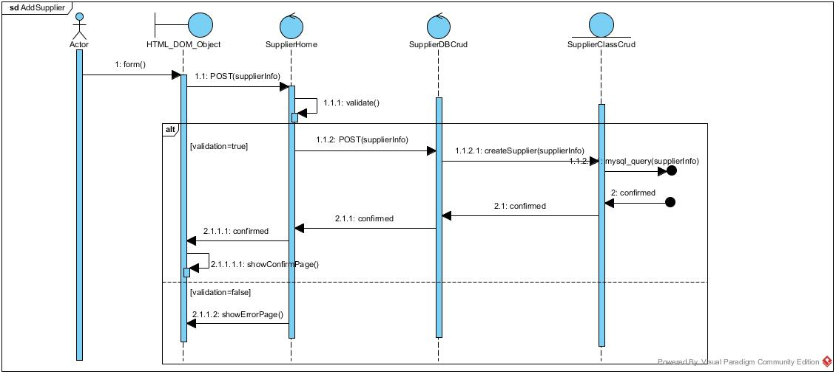

**Physical Diagram**

figure 11:

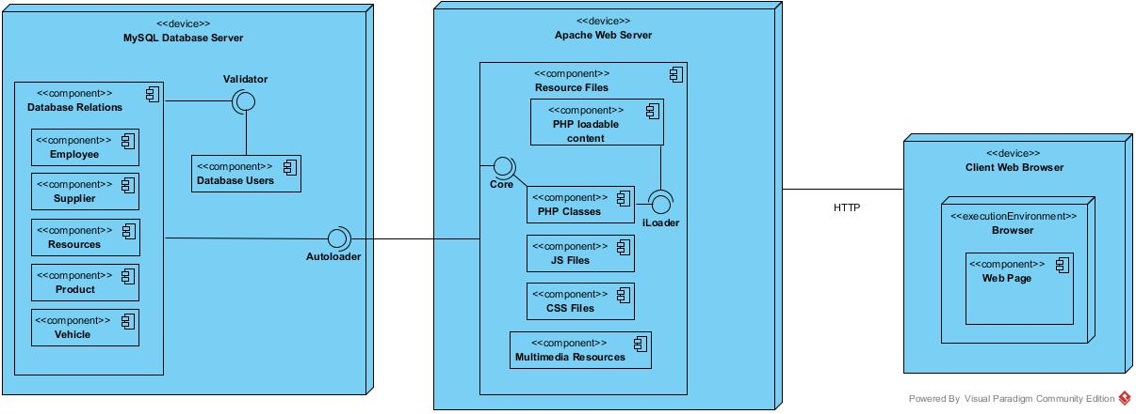

## Implementation

Database was created using My SQL 5.6.20 version which consist of the capability of producing results table efficient than the older versions. When we consider about PHP and HTML coding of the project Dbase class was created for connect with the database and redundancy of code was reduced by creating data returning methods inside separate class for each function.

**class Dbase {**

**private $_host = "localhost";**

**private $_user = "root";**

**private $_password = "";**

**private $_name = "radiant5";**

**private $_conndb = false;**

**public $_last_query = null;**

**public $_affected_rows = 0;**

**public $_insert_keys = array();**

**public $_insert_values = array();**

**public $_update_sets = array();**

**public $_id;**

**public function __construct() {**

**$this->connect();**

**}**

**private function connect() {**

**$this->_conndb = mysql_connect($this->_host, $this->_user, $this->_password);**

**if (!$this->_conndb) {**

**die("Database connection failed:<br />" . mysql_error());**

**}**

**else {**

**$_select = mysql_select_db($this->_name, $this->_conndb);**

**if (!$_select) {**

**die("Database selection failed:<br />" . mysql_error());**

**}**

**}**

**mysql_set_charset("utf8", $this->_conndb);**

**}**

**}**

**DBAccess Classes**

These classes contain all the methods and redundancy of whole code was reduced by creating these classes.

**class INVOICE extends Application**

**{**

**Public function Get_Sales_rep_teratory($username){**

**$query = "select teretoryId from employee where username='$username'";**

**$query2 = mysql_query($query);**

**$query3 = mysql_fetch_array($query2);**

**$ter = $query3['teretoryId'];**

**return $ter;**

**}**

**public function insert_invoice_details($routeId,$teretoryId,$shopId,$repId,$cDate,$nDate,$time){**

**mysql_query("insert into invoice(routeId,teretoryId,shopId,repId,cDate,nDate,TIMESTAM) values('$routeId','$teretoryId','$shopId','$repId','$cDate','$nDate','$time')");**

**//return last inserted Invoice number...**

**$id = mysql_insert_id();**

**return $id;**

**}**

**}**

**class STOCK extends Application**

**{**

**Public function Get_Sales_rep_teratory($username){**

**$query = "select teretoryId from employee where username='$username'";**

**$query2 = mysql_query($query);**

**$query3 = mysql_fetch_array($query2);**

**$ter = $query3['teretoryId'];**

**return $ter;**

**}**

**Public function Get_Sales_rep_teratory_name($teretory ){**

**$query = "select TeretoryName from teretory where TeretoryId ='$teretory'";**

**$query2 = mysql_query($query);**

**$query3 = mysql_fetch_array($query2);**

**$ter = $query3['TeretoryName'];**

**return $ter;**

**}**

**}**

**class AreaCRUD extends Application**

**{**

**Public function Get_areamanager_territory($username){**

**$query = "select teretoryId from employee where username='$username'";**

**$query2 = mysql_query($query);**

**$query3 = mysql_fetch_array($query2);**

**$ter = $query3['teretoryId'];**

**return $ter;**

**}**

**public function route_no_of_rows() {**

**$sql = mysql_query("SELECT * FROM route");**

**$count = mysql_num_rows($sql);**

**return $count;**

**}**

**}**

figure 12:

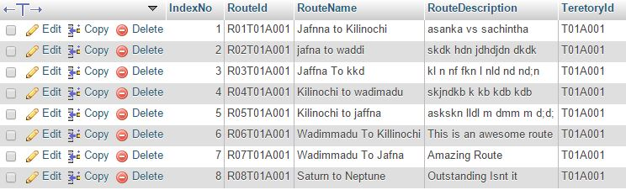

figure 13:

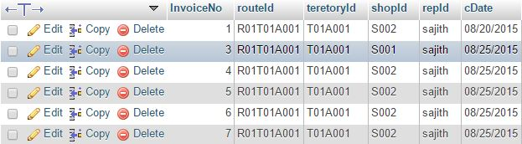

## Testing

In the testing process of the system we have followed many testing methods. First we followed Black Box testing to get an idea about the functions that the company needed. After the implementation of every function we did the White Box testing to confirm whether the particular function is working or not according to their requirements. We have done some performance testing to check whether the system is reached to company requirements. We checked each and every function of the departments that we have classified with the Unit Testing to identify whether those functions are applicable for the department. After complete the final system we did the System Testing, the testing that estimated the ultimate state of the product as a whole. Here also we did the modifications as needed to decrease the bugs and errors. As the final Testing of the System we implemented, we have to do the Acceptance Testing after handing over the system to the client. In this system also we will have to be able to do the modifications as required by the client accordingly.

# Evaluation

## Assessment of the Project results

Assessing was done by the Academic panel of the SLIIT. Our Supervisor Mr. Ishara Gamage, provided us relevant guidelines from the beginning of the project to the end. We have passed several steps of this project such as Proposal presentation, Prototype presentation and finally we are going to do Final presentation. All of these steps we have created related documents under advisors of Mr. Ishara Gamage who is our supervisor.

## Lessons Learned

There were lots of lessons that we learned from throughout the developing time. Most important thing we learned is how to work according to a time schedule and how to manage time. We faced lot of problems when divide the time among the functions. This project was also get us the experience of group work and how to work with a group. We were solved lot of problems by discussing the problems with the group. There were lot of experiments we got and it was very useful us to improve our knowledge as well as to our lives.

## Future Work

Science the beginning of the project up to now we have realized 3 versions of our system and we have to develop lot of things in the future. Mainly now we are using we base solution to generate invoices and with next release we are planning to develop android application for this purpose. Also we are going to develop this project using MVC framework such as Laravel to increase the security of our system. Also now we are going to give this system for the sales representatives. After get their ideas we are fixed those modifications also errors.

# Conclusion

The project we developed is the Sales Management System for the Radiant confectioner company. The System gives solution for most of the problems that we have identified in the company currently. The entire task mostly was handled manually by the management and the employees work at the Radiant confectioner company. The System we are going to introduce will address those identified problems accordingly.

The Sales management System is built to find suitable solution of daily sales activities, goods, payment, area management, employee management, vehicles management, inventory management, routes management, database backup for the company .This System deals with the database as an end back which is based on php myadmin SQL server and its interfaced based on BOOTSTRAP ,PHP,HTML5,CSS,JAVASCRIPT. The Interface aims to make easy to use system tools to everyone without needing to learn how to use.

The System that is going to be handed over to the client will address most of the problems in the company currently. The system has a login function that will make the company’s all the tasks secure .Only the selective user can log into the system and access the database. The tasks that are carried out manually will be able to do with the system in more easy way. The data that are now kept in large physical files will be stored in the centralized database of the system. That will reduce the damages that can be happened unexpectedly. The calculations that are done manually will be able to do through System to get more accurate results. Presently the information regarding area, shops, products, employees, vehicles, inventory, route, payments are handled manually. The System that is introducing give the ability to handle them through the system in a more conveniently and accurately. The details of the daily sales, goods can be inserted to the system easily and retrieve them whenever user requires. Records and details of the inventory are also handled through the proposed system with giving the solutions for the problems that arise with the current manual procedure of the company.

Those features of the introducing system will call upon the problems that we have encountered from the current system that is prevailing in the company now to make the tasks done at the company comfortably and much more efficiently.

# References

Books:

1]R. Elmasri and S. Navathe, Fundamentals of database systems. Redwood City, Calif.: Benjamin/Cummings, 1989.

[2]R. Nixon, Learning PHP, MySQL, and JavaScript. Beijing: O'Reilly, 2009.

[3]M. Fowler and K. Scott, UML. Paris: CampusPress, 2001.

[4]I. Sommerville, Software engineering. Harlow, England: Addison-Wesley, 2000.

[5]K. Pries and J. Quigley, Scrum project management. Boca Raton, FL: CRC Press, 2011.

World Wide Web:

[5]Lauesen, S, (2003), Task Descriptions as Functional Requirements, IEEE Computer Society,

Retrieved from <http://www.itu.dk/~slauesen/Papers/IEEEtasks.pdf>

[6] lynda.com, 'lynda.com Training | PHP with MySQL Essential Training', 2015. [Online]. Available: <http://www.lynda.com/MySQL-tutorials/PHP-MySQL-Essential-Training/119003-2>. html . [Accessed: 29- Jul- 2015].

[7] W3schools.com, 'PHP 5 Tutorial', 2015. [Online]. Available: http://www.w3schools.com/php/default.asp. [Accessed: 29- Jul- 2015].

[8] W3schools.com, 'Bootstrap 3 Tutorial', 2015. [Online]. Available: http://www.w3schools.com/bootstrap/. [Accessed: 29- Jul- 2015].

[9] YouTube, 'Codecourse', 2015. [Online]. Available: https://www.youtube.com/user/phpacademy. [Accessed: 29- Jul- 2015].

[10] lynda.com, 'lynda.com Training | PHP with MySQL Beyond the Basics', 2015. [Online]. Available: http://www.lynda.com/PHP-tutorials/php-with-OOP-beyond-the-basics/653-2.html. [Accessed: 29- Jul- 2015].

# Appendix A: Design Diagrams

figure 14:

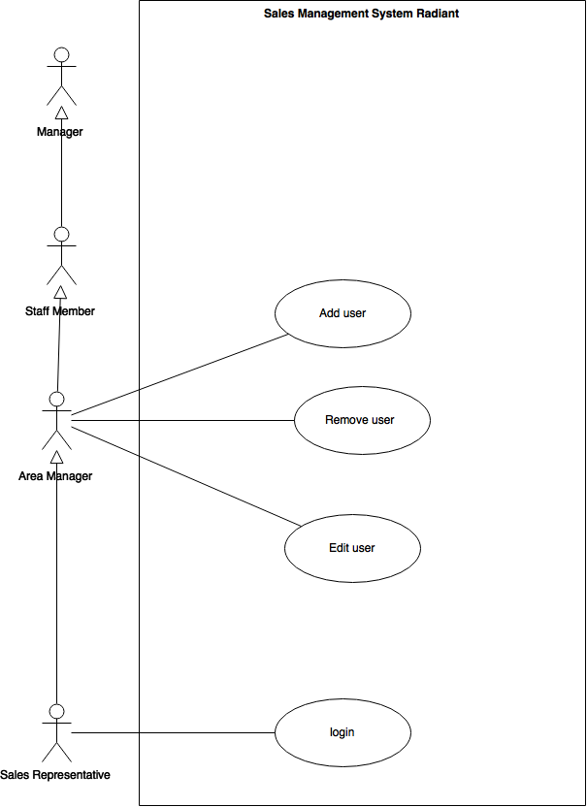

figure 15:

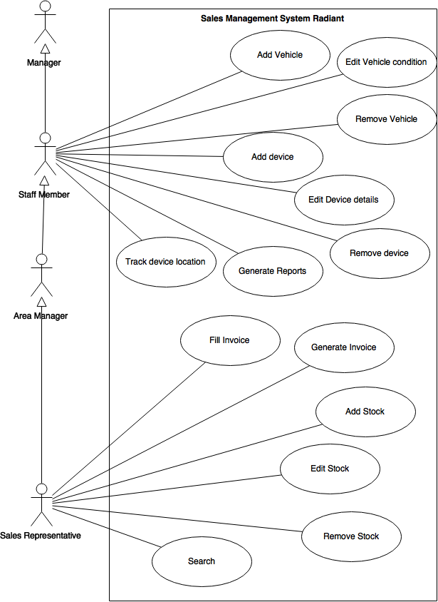

figure 16: